**Project Report**

**Toronto,**

**Neighbourhood exploring for new person to decide better option of neighbourhood,**

**Project Description:**

Whenever people move to any other place, they explore the place and try to fetch as much information as possible about it. It can be the neighborhood, locality, market, price of the place and many more factors including neighborhood analysis. This is can be termed as request for a search algorithm which usually returns the requested features such as population rate, median house price, school ratings, crime rates, weather conditions, recreational facilities etc.

It would be beneficial and nice to have an application which could make easy by considering a comparative analysis between the neighborhood with provided factors.

These analysis can be used for business purpose or personal basis for new person coming to the town

This project helps the end user or the stakeholder to achieve the results which will not only recommend but also saves a lot of time in manual search. This will indeed save the time and money of the user.

This project can be used by the user at the time of rental apartment or buy house in a locality based on the distribution of various facilities available around the neighborhood. As an example, this project would compare 2 randomly picked neighborhoods and analyses the top 10 most common venues in each of those two neighborhoods based on the number of visits by people in each of those places. Also, this project uses K-mean clustering unsupervised machine learning algorithm to cluster the venues based on the place category such as restaurants, park, coffee shop, gym, clubs etc.

This project give a better understanding of the similarities and dissimilarities between the two chosen neighborhoods to retrieve more insights and to conclude with ease which neighborhood wins over other, feel free to change the neighborhood in the given cell or even you can add more neighborhood for the comparison purpose.

### Data and APIs:

**Foursquare API**: This API has a database of more than 105 million places. This project would use Four-square API as its prime data gathering source. Many organizations are using to geo-tag their photos with detailed info about a destination, while also serving up contextually relevant locations for those who are searching for a place to eat, drink or explore. This API provides the ability to perform location search, location sharing and details about a business. Foursquare users can also use photos, tips and reviews in many productive ways to add value to the results.

Scrap data from the following link: : <https://en.wikipedia.org/w/index.php?title=List_of_postal_codes_of_Canada:_M&oldid=995657573>

#### API Request

HTTP requests would be made to this Foursquare API server using zip codes of the Toronto city neighborhoods to pull the location information. Foursquare API search feature would be enabled to collect the nearby places of the neighborhoods. Due to http request limitations the number of places per neighborhood parameter would reasonably be set to 100 and the radius parameter would be set to 1500

**Folium- Python visualization library** would be used to visualize the neighborhoods cluster distribution of Toronto city over an interactive leaflet map. Extensive comparative analysis of two randomly picked neighborhoods world be carried out to derive the desirable insights from the outcomes using python’s scientific libraries Pandas, NumPy and Scikit-learn.

**Unsupervised machine learning algorithm K-mean clustering** would be applied to form the clusters of different categories of places residing in and around the neighborhoods. These clusters from each of those two chosen neighborhoods would be analyzed individually collectively and comparatively to derive the conclusions.

#### Python packages and Dependencies:

* Pandas - Library for Data Analysis
* NumPy – Library to handle data in a vectorized manner
* JSON – Library to handle JSON files
* Geopy – To retrieve Location Data
* Requests – Library to handle http requests
* Matplotlib – Python Plotting Module
* Sklearn – Python machine learning Library
* Folium – Map rendering Library
* BeautifulSoup - Reading data from link

**Methodology**

This workflow start with the web scraping the data wrangling. Using the beautiful Soup library, postal codes and neighbourhood is processed and derive latitude and longitude of the Toronto neighbourhood.

With the Folium map, latitude and longitude of the Toronto neighbourhood provide the choropleth visualization.

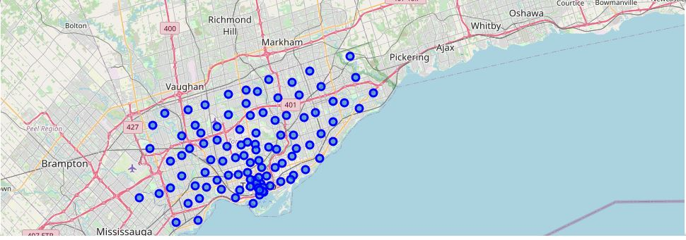

**Four Square API** and K-means clustering methods are used to retrieve the top trend venues of the Toronto neighbourhood.

Elbow criterion method is used here to the optimum number of cluster present in the data set .

Silhoutte Co-efficient analysis also used to find the number of cluster.

In this project , decision of buying, rental or setting up the market is recommended base on the clustered neighbourhood, Population distribution analysis, School ratings, Median house prices analysis.

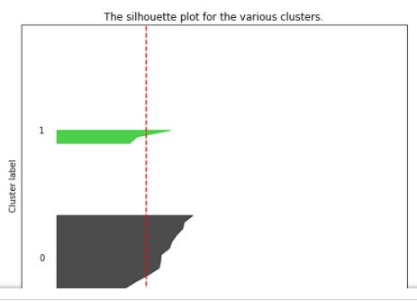

**Cluster Map** 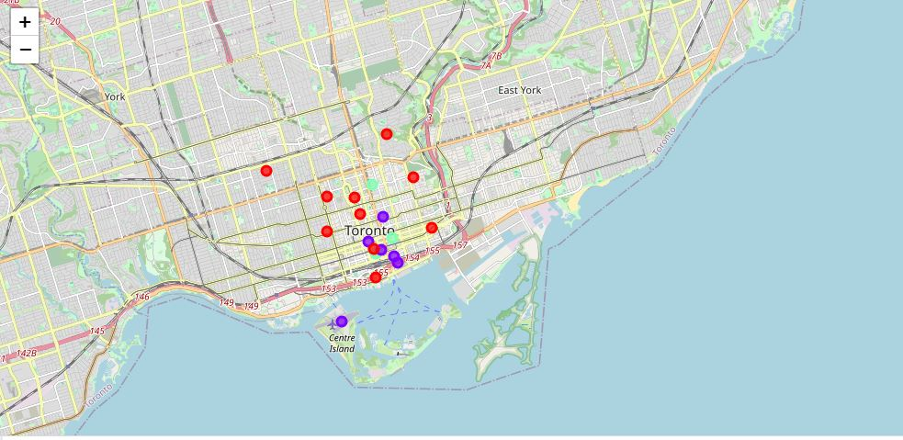

Cluster venues obtained from above methodology, showing only top result for discussion purpose.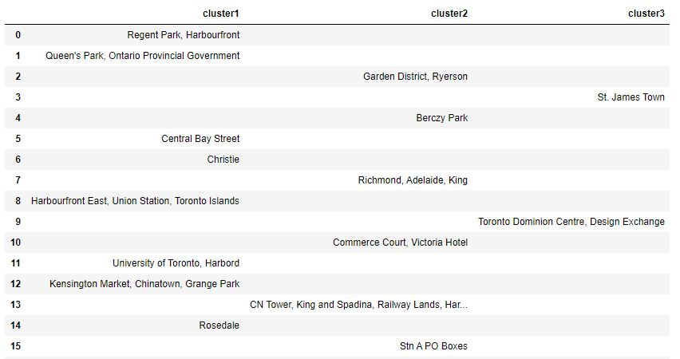

**Results:**

With the help of above Methodologies , the project can easily help user to decide which neighbourhood is better to stay based on the factors of number of population, Localities, School ratings of the targeted neighbourhood and availability of top trend venues.

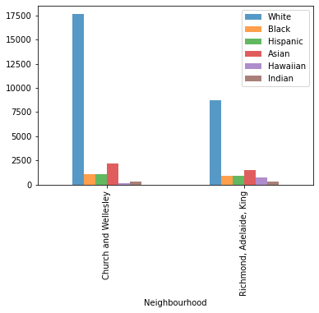

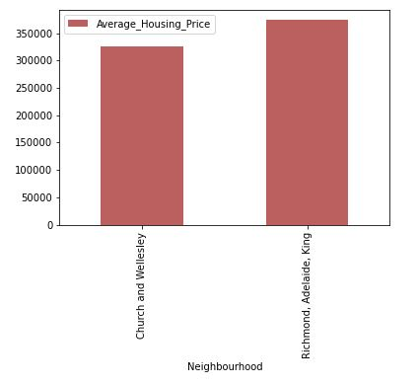

**Discussion:**

This project is beneficial in many terms; it will save the users time and cost. Often people moved to new place they are worried to settle down and deciding best place as per the one’s priorities, this project would recommend places of their choices in short span of time.

**Conclusion:**

This Analysis concludes that the two places of Toronto Neighborhood, Preview both has great amenities and locality, but out of these two, one has better prospects for buying houses or choose for rental houses. One has the higher number of Indian population ,good school rating of 9 and a reasonable avge housing price of around 373k ,also top 10 common venues shows one has got a good neighborhood with Gas station, Italian and American Restaurants, Train Station, Clothing Store , Park, Donot Shop and many more.

This study helps user to compare two neighborhoods and recommend options with facts